Section 2 Notes
What factors contribute to the diffusion of golf?
- -What are some advancements in transport telecommunications that led to the diffusion of golf?
- -How did the role of Trans-National Corporations (TNC’s) diffuse golf?

- For most of human history information could not travel faster than the person carrying it such as on a horse, ship or train. Information could travel faster than human such as aeroplanes, carrier pigeons and smoke signal. Over the last two centuries, the distance in kilometres between places have stayed the same, however the distance in time has shortened due to improvements in transport and telecommunication technology. Advancements in transport and telecommunication helped the diffusion of golf to all parts of the world. Examples of transport advancements that helped diffuse golf include Containerization, steam ships, aeroplanes, and trains. Examples of telecommunication advancements that helped diffuse golf include television, advertising, radio and the internet, (social media).
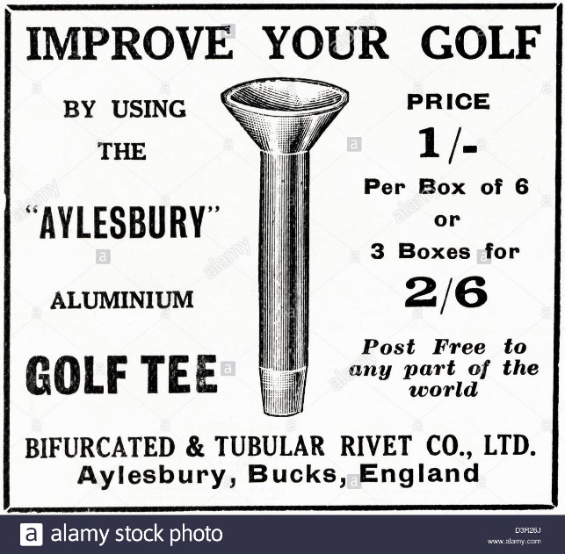
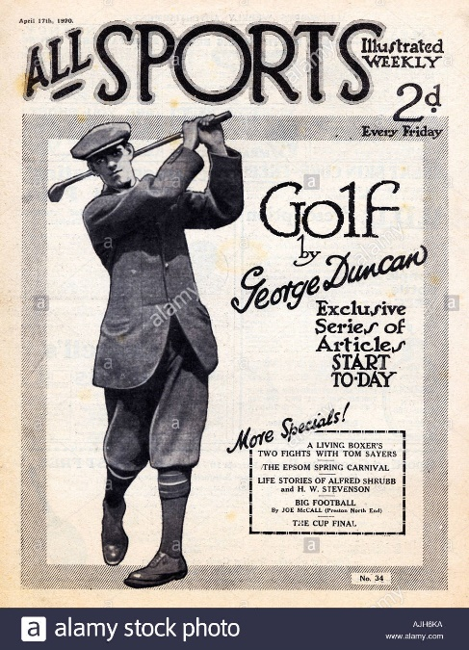

To the right is the logo of the PGA Tour which was started in 1929.
https://en.wikipedia.org/wiki/PGA_Tour#/media/File:PGA_Tour_logo.svg

Original 1920s vintage print advertisement from English country gentleman's newspaper and advertising aluminium golf tee by the Bifurcated & Tubular Rivet Co. of Aylesbury Bucks. https://www.alamy.com/stock-photo-original-1920s-vintage-print-advertisement-from-english-country-gentlemans-53981722.html

1920s Uk Golf 1920s Magazine. https://www.alamy.com/stock-photo/1920s-uk-golf-1920s-magazine.html

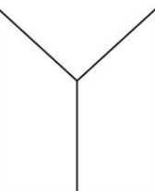
What are some advancements in telecommunications that led to the diffusion of golf?
Golf has become an increasingly popular sport in the past century and media can credit itself for the substantial impact on this sport. Professional players didn't have any outlets before social media to communicate their stories and daily lives with a larger audience than the members of their country clubs. In order to achieve greater popularity and attention, golfers nowadays frequently communicate with their fans and share golfing videos. (Rickie Fowler, who has 5 million followers on all social media platforms, often shares photos and videos of him at junior golfing and charity events.)
Radio broadcasting has led to the diffusion of golf because it let people be able to listen to the professional scores and the commentating of the big tournaments such as the US Masters. Radio also changed the way Society saw sports. The introduction of radio play-by-play explanations of sporting events brought sports enjoyment into the homes of millions of people. Radios became a dominant feature in American homes in the 1920s after being introduced during World War I. Over the course of the decade, hundreds of radio stations popped up.
Print advertising, Advertisements in print can be seen in newspapers or magazines, and they are occasionally combined with brochures or posters. Print advertising includes anything written with a goal to attract the attention of a specific target audience. People who read newspapers or other media have just a tendency for looking through the print advertisements that they come across. Print advertising would have aided in the diffusion of golf in the 1900’s because everyone was using newspapers that had ads about golf.
Television, because of television, the diffusion of golf has remarkably increased. This is because golf is seen on sporting channels for everyone to watch. The big tournaments and pro players can be viewed on television for new and current golf players without leaving their home, such as Tiger Woods or the British open. Advertising is also commercialised on TV for golf, which also influences the diffusion of clubs and equipment to other countries.

What are some advancements in transport that led to the diffusion of golf?
Containerization allows loads of goods to be moved on, off and between ships, trains and trucks much more easily. Containerization allows golfing equipment such as clubs, gloves, shoes, balls etc. to be transported to different countries in bulk amounts, cheaply, which is more inviting to new players because it is seen as not a wealthy person sport anymore and there are cheaper ways to be able to play.
Steam ships were once the only way for transport between countries which had an impact because it allowed professionals to play in different competitions across the world. Steam ships also developed because of containerization.
Trains were a fast way for professionals and/or golf products to travel across land to other cities or countries. St Andrews (home of golf) railway station served the town of St Andrews, Fife, Scotland from 1887 to 1969 on the St Andrews Railway and the Anstruther and St Andrews Railway.
Aeroplanes is the modern and fast way for professionals to get across the world to play golf tournaments. Aeroplanes are becoming cheaper to use now and because of this people can fly over to golf courses they dream of playing aswell as the professionals to play in Australia one day then in Scotland in a few days instead of a few weeks for example.

How did the role of TNC’s diffuse golf? E.g PGA
Trans-National Corporations (TNC’s) or multinational corporations are companies that operate in more than one country, an example of this is the PGA TOUR. PGA TOUR members come from around the world. In 2020-21, there are 96 international members from 29 countries and outside the United States. The 2020-21 PGA TOUR Schedule includes 50 official FedEx Cup tournaments, in addition to the men's Olympic Golf competition.
The PGA of America evolved into mostly a club professional organisation, but it kept control of two major events: the PGA Championship and the Ryder Cup. Due to the United States' expected dominance, the Ryder Cup was an obscure match play team event that was not very popular with golf fans. It became increasingly competitive after the addition of players from continental Europe in 1979 and improved television coverage, and it evolved into the main international team event, which is currently dominated by Europe. Both events generate significant money for the PGA of America.

